Herpes Simplex Virus type 1 and Alzheimer’s disease

Zhichang Huang

**Introduction**

Alzheimer’s disease (AD) is a neurodegenerative disease that impairs thinking, behavior, and memory. Eventually, symptoms become severe enough to obstruct daily activities(Alzheimer's Association, 2016). However, the cause of the disease is ambiguous. In recent years, a greater focus on AD pathogenesis has been placed on the infectious agent. Debates of whether Herpes Simplex Virus 1 causes Alzheimer’s disease appear frequently in the scientific research field. More and more evidence indicates pathogen of AD is related to HSV-1. The present review describes 1)Introduction to HSV; 2)Mechanism and effect of HSV-1 infection in the brain; 3) HSV-1 and Alzheimer’s disease; 4) APOE, HSV, and AD; 5)Available treatment for the HSV-1 infection.

**Introduction to HSV**

One of the most common human viral pathogens is HSV-1. There are two forms of the herpes simplex virus (HSV): HSV-1 and HSV-2. HSV-1 is most commonly spread by oral-to-oral contact. It causes oral herpes, which includes symptoms known as cold sores. Genital herpes can be caused by both HSV-1 and HSV-2 (World Health Organization, 2022). The virus is very prevalent among humans and may reach and infect the central nervous system.

**Mechanism and effect of HSV-1 infection in the brain**

HSV-1 is a neurotropic virus, it will infect the peripheral tissue and then the peripheral nervous system. When the first infection happens in the epithelial cells, the virus will diffuse to the peripheral nervous system (PNS) by retrograde transport. It developed latency associate transcripts (LAT) in trigeminal ganglia (TG) (Roizman et al., 2011) and begins its lifelong latency mainly in the sensory neurons. HSV-1 establishes an asymptomatic infection that only miRNA can be expressed and HSV-1 destroys the infected non-neuronal cells while neuronal cells survive (Du et al., 2011). Additionally, the virus can be reactivated by events like inflammation and stress. One of the popular factors is immunosenescence (Linard et al., 2020). Elder people show immunosenescence and have a greater tendency to AD pathology than young people.

Then it can travel to the epithelial tissues from sensory neurons by anterograde transport along the axon (DuRaine & Johnson, 2021). After being released at the nerve terminal, it will start a cycle of lytic replication in uninfected cells and neurons (Ibáñez et al., 2018). The spread of the virus will attribute to further infection of the central nervous system. Compared to PNS which the nerves direct contact with the infection and viruses, CNS is well protected by the blood-brain barrier (BBB), which is mainly composed of the basement membrane, astrocytes, endothelial cells, and pericytes (figure 1D). BBB limits the infection to spread to the cerebral spinal from the blood (Koyuncu et al., 2013). Virus infections can enter the PNS or CNS from the periphery by directly infecting nerve terminals in the tissues or by infecting circulatory system cells that then pass the infection over the BBB and into the CNS (figure 1A & 1B). Reactivation may occur in the same region in the peripheral nervous system, and repeatedly reactivation will cause the (Dobson & Itzhaki, 1999)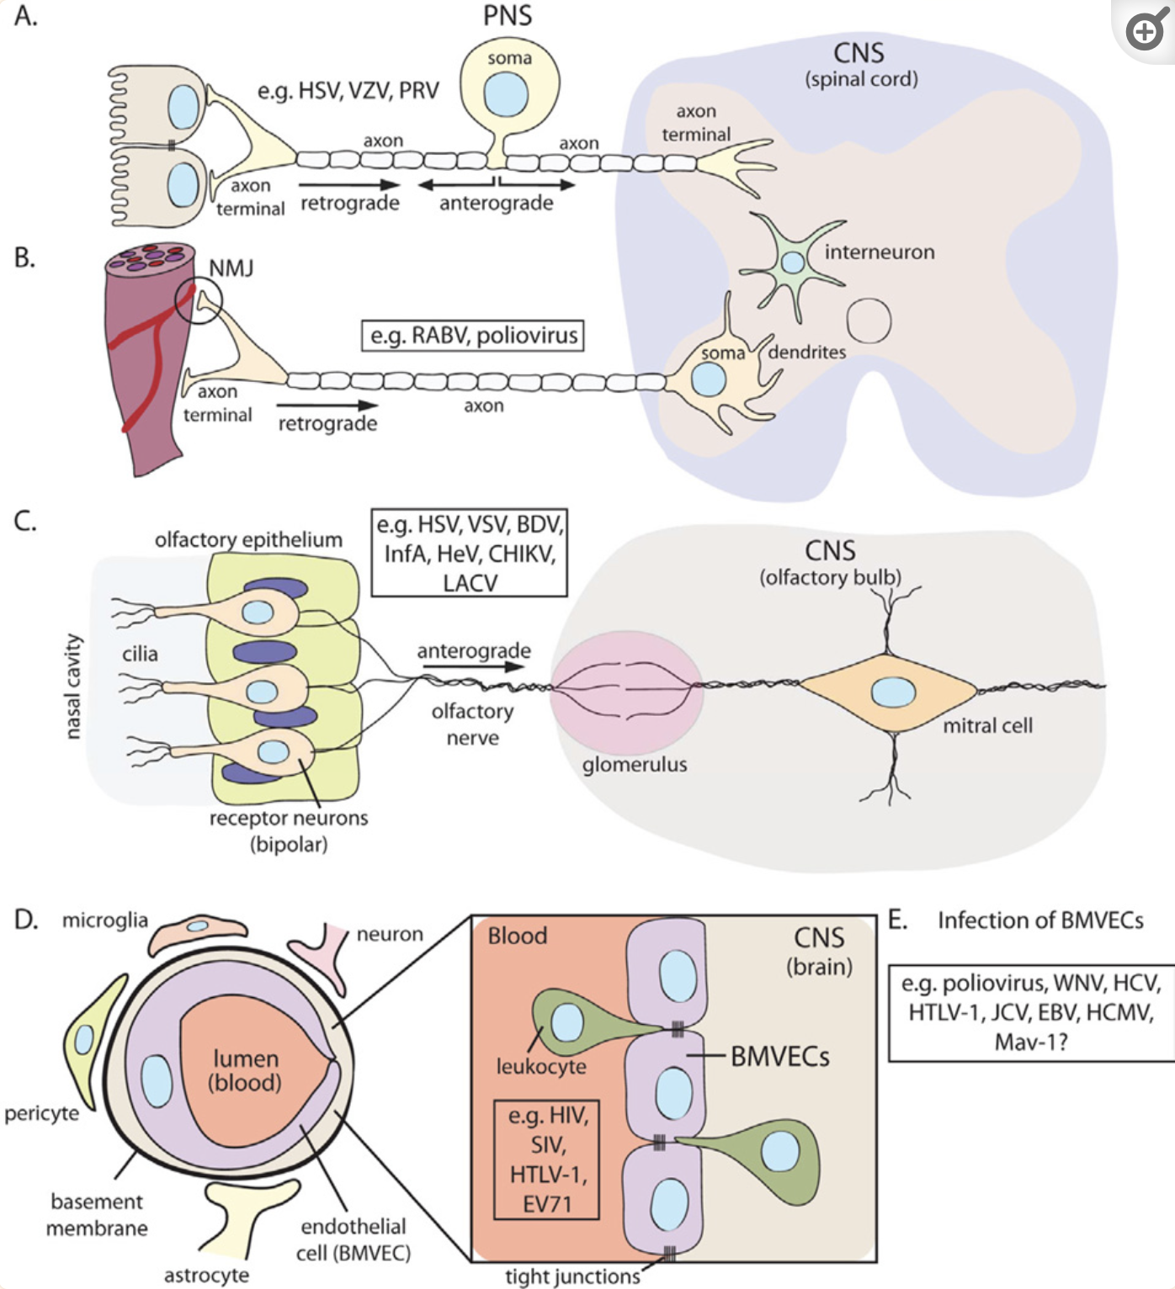

From “Virus Infections in the Nervous System,” by Koyuncu et al., 2013.

**HSV-1 and Alzheimer’s disease**

Epidemiological research findings suggest that HSV-1 participates in the pathogenesis of Alzheimer’s disease. HSV-1 will affect the integral transmembrane amyloid precursor protein(APP) processing in the neuronal cell (De Chiara et al., 2010). Researchers find out that after infection of rat cortical neurons and SH-SY5Y human neuroblastoma cells, APP is repeatedly cleaved, leading to the intra/extra-cellular accumulation of different neurotoxic species, which includes APP fragments (APP-Fs) of 35 and 45 kDa that build up part of the Aβ, N-terminal APP-Fs, Aβ(1-40) and A(1-42), and intracellular C-terminal APP-Fs. These results show that HSV-1 infection of neuronal cells can produce a variety of APP fragments with well-known neurotoxic potentials. Additionally, with the reduplicative re-activation of HSV-1 from latency can result in a massive accumulation of APP fragments inside and outside of the cells, which further contributes to the development of AD.

**APOE, HSV, and AD**

Apolipoprotein E (ApoE) is a significant cholesterol transporter that aids in the transfer of lipids and the repair of brain damage. The primary genetic factors that influence the risk for Alzheimer's dementia (AD) are APOE polymorphism alleles (Liu et al., 2013). Studies show that the APOE epsilon4 allele possesses greater risks for AD than other genotypes (Farrer et al., 1997). Moreover, there are evidences show that there is a strong relationship between APOE-e4 and HSV-1 together imposing a greater tendency of AD (Itzhaki et al., 1997). A combination of APOE epsilon4 allele carrier and HSV-1 positive in the brain tends to have greater risks of developing AD. HSV-1 in the brains of people who are not APOE-e4 carriers possess less or even no risks of AD development. APOE-e4 is a major factor that causes herpes labials. However, this does not represent that people who have the APOE-e4 genotype are at a greater risk of infecting HSV-1. The presence of the HSV-1 genome in the brain of a small number of APOE-e4 carrier AD individuals indicates the genetic correlation of AD and HSV-1 reoccurrence. More evidence shows that elderly people with increased occurrence of positive detection anti-HSV IgM antibodies and avidity of anti-HSV-1 immunoglobulin G (IgG), both of which indicate the sign of reoccurrence of HSV-1 (Letenneur et al., 2008). Therefore, aging people have increased risks of AD along with the potential reactivation of HSV-1, especially among APOE-e4 carriers.

**Potential treatment**

After the relationship between AD and HSV-1 is proven, the treatment for the viral infection tends to show effectiveness in preventing AD. A crucial part of the HSV-1 infection, which is the replication of HSV-1, can be inhibited by an antiviral drug like acyclovir (ACV), foscarnet, penciclovir (James & Prichard, 2014). These drugs further reduce the formation of Aβ and HSV-1-driven tau phosphorylation (Protto et al., 2022). The feasibility and effectiveness of applying the antiviral treatment on HSV-1 on preventing AD are supported by the research study on electronic health databases (Tzeng et al., 2018). After 10 years, Taiwanese patients who had been diagnosed with HSV have a higher risk of 2.56 of developing AD, compared to people who have never been infected with HSV. Additionally, it is worth mentioning that fewer HSV-1 patients who receive antiviral treatment and drugs have Alzheimer’s disease than those who didn’t receive the treatment. Therefore, based on the evidence, the potential method of AD prevention can be generated from the treatment of HSV.

**Conclusion**

The latency of HSV-1 in the human brain together with the effect of APOE-e4 might raise the concern of majority. Researches show that there are still possibilities to prevent the development of Alzheimer’s disease at an early stage. More scientific discoveries on treatment and increased people’s knowledge about HSV-1 can prevent the spread of the virus and early treatment can begin before the severe damage.

**Bibliography:**

1. Alzheimer's Association. (2016). 2016 Alzheimer’s disease facts and figures. *Alzheimer’s & Dementia*, *12*(4), 459–509. <https://doi.org/10.1016/j.jalz.2016.03.001>
2. World Health Organization. (2022, March 10). *Herpes simplex virus*. Who.int; World Health Organization: WHO. <https://www.who.int/news-room/fact-sheets/detail/herpes-simplex-virus>
3. Roizman, B., Zhou, G., & Du, T. (2011). Checkpoints in productive and latent infections with herpes simplex virus 1: conceptualization of the issues. *Journal of NeuroVirology*, *17*(6), 512–517. <https://doi.org/10.1007/s13365-011-0058-x>
4. Du, T., Zhou, G., & Roizman, B. (2011). HSV-1 gene expression from reactivated ganglia is disordered and concurrent with suppression of latency-associated transcript and miRNAs. *Proceedings of the National Academy of Sciences*, *108*(46), 18820–18824. <https://doi.org/10.1073/pnas.1117203108>
5. Linard, M., Letenneur, L., Garrigue, I., Doize, A., Dartigues, J.-F., & Helmer, C. (2020). Interaction between APOE4 and herpes simplex virus type 1 in Alzheimer’s disease. *Alzheimer’s & Dementia*, *16*(1), 200–208. https://doi.org/10.1002/alz.12008
6. DuRaine, G., & Johnson, D. C. (2021). Anterograde transport of α-herpesviruses in neuronal axons. *Virology*, *559*, 65–73. <https://doi.org/10.1016/j.virol.2021.02.011>
7. Ibáñez, F. J., Farías, M. A., Gonzalez-Troncoso, M. P., Corrales, N., Duarte, L. F., Retamal-Díaz, A., & González, P. A. (2018). Experimental Dissection of the Lytic Replication Cycles of Herpes Simplex Viruses in vitro. *Frontiers in Microbiology*, *9*. https://doi.org/10.3389/fmicb.2018.02406
8. Koyuncu, Orkide O., Hogue, Ian B., & Enquist, Lynn W. (2013). Virus Infections in the Nervous System. *Cell Host & Microbe*, *13*(4), 379–393. <https://doi.org/10.1016/j.chom.2013.03.010>
9. Dobson, C. B., & Itzhaki, R. F. (1999). Herpes simplex virus type 1 and Alzheimer’s disease. *Neurobiology of Aging*, *20*(4), 457–465. https://doi.org/10.1016/s0197-4580(99)00055-x
10. De Chiara, G., Marcocci, M. E., Civitelli, L., Argnani, R., Piacentini, R., Ripoli, C., Manservigi, R., Grassi, C., Garaci, E., & Palamara, A. T. (2010). APP Processing Induced by Herpes Simplex Virus Type 1 (HSV-1) Yields Several APP Fragments in Human and Rat Neuronal Cells. *PLoS ONE*, *5*(11), e13989. <https://doi.org/10.1371/journal.pone.0013989>
11. Liu, C.-C., Kanekiyo, T., Xu, H., & Bu, G. (2013). Apolipoprotein E and Alzheimer disease: risk, Mechanisms and Therapy. *Nature Reviews Neurology*, *9*(2), 106–118. https://doi.org/10.1038/nrneurol.2012.263
12. Farrer, L. A., Cupples, L. A., Haines, J. L., Hyman, B., Kukull, W. A., Mayeux, R., Myers, R. H., Pericak-Vance, M. A., Risch, N., & van Duijn, C. M. (1997). Effects of age, sex, and ethnicity on the association between apolipoprotein E genotype and Alzheimer disease. A meta-analysis. APOE and Alzheimer Disease Meta Analysis Consortium. *JAMA*, *278*(16), 1349–1356. <https://pubmed.ncbi.nlm.nih.gov/9343467/>
13. Itzhaki, R. F., Lin, W.-R., Shang, D., Wilcock, G. K., Faragher, B., & Jamieson, G. A. (1997). Herpes simplex virus type 1 in brain and risk of Alzheimer’s disease. *The Lancet*, *349*(9047), 241–244. <https://doi.org/10.1016/s0140-6736(96)10149-5>
14. Letenneur, L., Pérès, K., Fleury, H., Garrigue, I., Barberger-Gateau, P., Helmer, C., Orgogozo, J.-M., Gauthier, S., & Dartigues, J.-F. (2008). Seropositivity to herpes simplex virus antibodies and risk of Alzheimer’s disease: a population-based cohort study. *PloS One*, *3*(11), e3637. <https://doi.org/10.1371/journal.pone.0003637>
15. James, S. H., & Prichard, M. N. (2014). Current and future therapies for herpes simplex virus infections: mechanism of action and drug resistance. *Current Opinion in Virology*, *8*, 54–61. <https://doi.org/10.1016/j.coviro.2014.06.003>
16. Protto, V., Marcocci, M. E., Miteva, M. T., Piacentini, R., Li Puma, D. D., Grassi, C., Palamara, A. T., & De Chiara, G. (2022). Role of HSV-1 in Alzheimer’s disease pathogenesis: A challenge for novel preventive/therapeutic strategies. *Current Opinion in Pharmacology*, *63*, 102200. <https://doi.org/10.1016/j.coph.2022.102200>
17. Tzeng, N.-S., Chung, C.-H., Lin, F.-H., Chiang, C.-P., Yeh, C.-B., Huang, S.-Y., Lu, R.-B., Chang, H.-A., Kao, Y.-C., Yeh, H.-W., Chiang, W.-S., Chou, Y.-C., Tsao, C.-H., Wu, Y.-F., & Chien, W.-C. (2018). Anti-herpetic Medications and Reduced Risk of Dementia in Patients with Herpes Simplex Virus Infections—a Nationwide, Population-Based Cohort Study in Taiwan. *Neurotherapeutics*, *15*(2), 417–429. https://doi.org/10.1007/s13311-018-0611-x